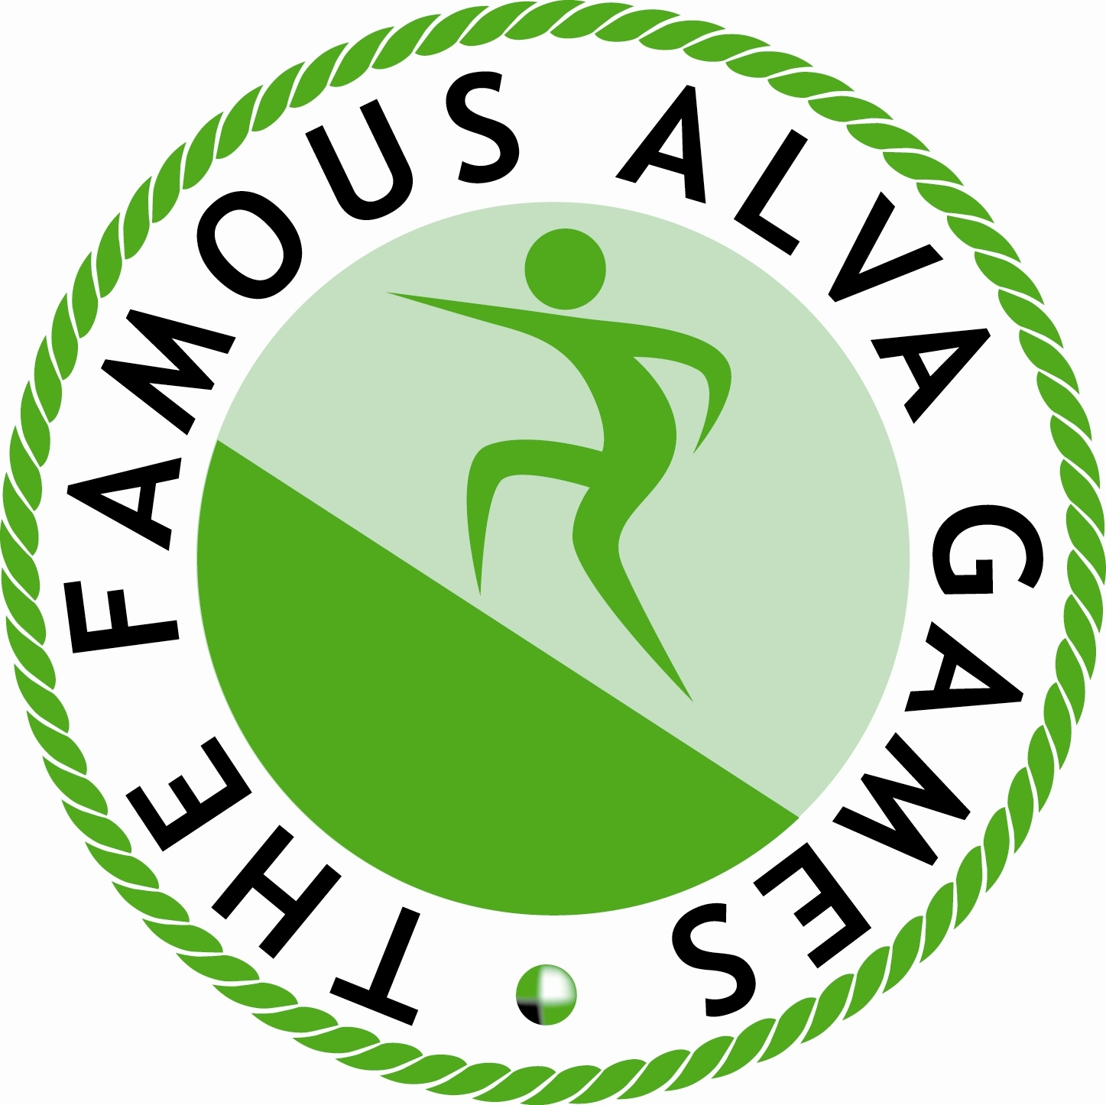THE FAMOUS ALVA GAMES

Games Secretary

Craig Dunbar, 57 Broomridge Road, Stirling FK7 0DT Telephone 01786 813523
e-mail: alvagamessec@btinternet.com
www.alvagames.co.uk

Saturday 8th July 2023 - First Arena Event – 12 noon

Come and take part in the most spectacular hill race in the country including the British Championship and British Junior Hill Race Championship (under 17) with separate races for each of under 14 and under 12 competitors. Age is determined by competitor’s age on 1st May 2023. Entry on the day possible (you pay to enter the Games - £8 for adults £4 for youths but thereafter entry to the race is free) but for name to appear in programme please pre-register by supplying name, age group and hometown (or club) not later than 20th June 2023 by email or post to the Games Secretary as shown above or through our Facebook page The Famous Alva Games.

BRITISH CHAMPIONSHIP HILL RACE (Off time – 4.15pm approx)

1st 2nd 3rd 4th 5th 6th 7th 8th 9th 10th
£175 £100 £50 £25 £10 £10 £10 £10 £10 £10
Prizes paid to first ten gents AND first ten ladies AND
First Veteran Male and female in each of V40, V45, V50 + V60 - £25 (8 prizes)

First Local (Clackmannanshire) (male or female) Runner - £25 AND

First runner to summit - £70.00 - donated by Colin Lindsay of Menstrie.

BRITISH JUNIOR HILL RACE CHAMPIONSHIP (Under 17) (off time – 3pm approx)

1st 2nd 3rd 4th 5th 6th
£75 £30 £20 £10 £10 £10

Prizes paid to first six gents AND first six ladies AND

First Local (Clackmannanshire) (male or female) Runner - £10

UNDER 14 HILL RACE & UNDER 12 HILL RACE (Two Separate Races are Run)
Under 12 race due off at 1pm approx and under 14 at 2pm approx

1st 2nd 3rd 4th 5th 6th
£40 £30 £20 £5 £5 £5

Prizes paid to first six boys AND first six girls AND
First Local (Clackmannanshire) (male or female) Runner in each Race - £10

ALL runners taking part in the age restricted races and completing the course will receive a signed certificate with details of the performance achieved.

