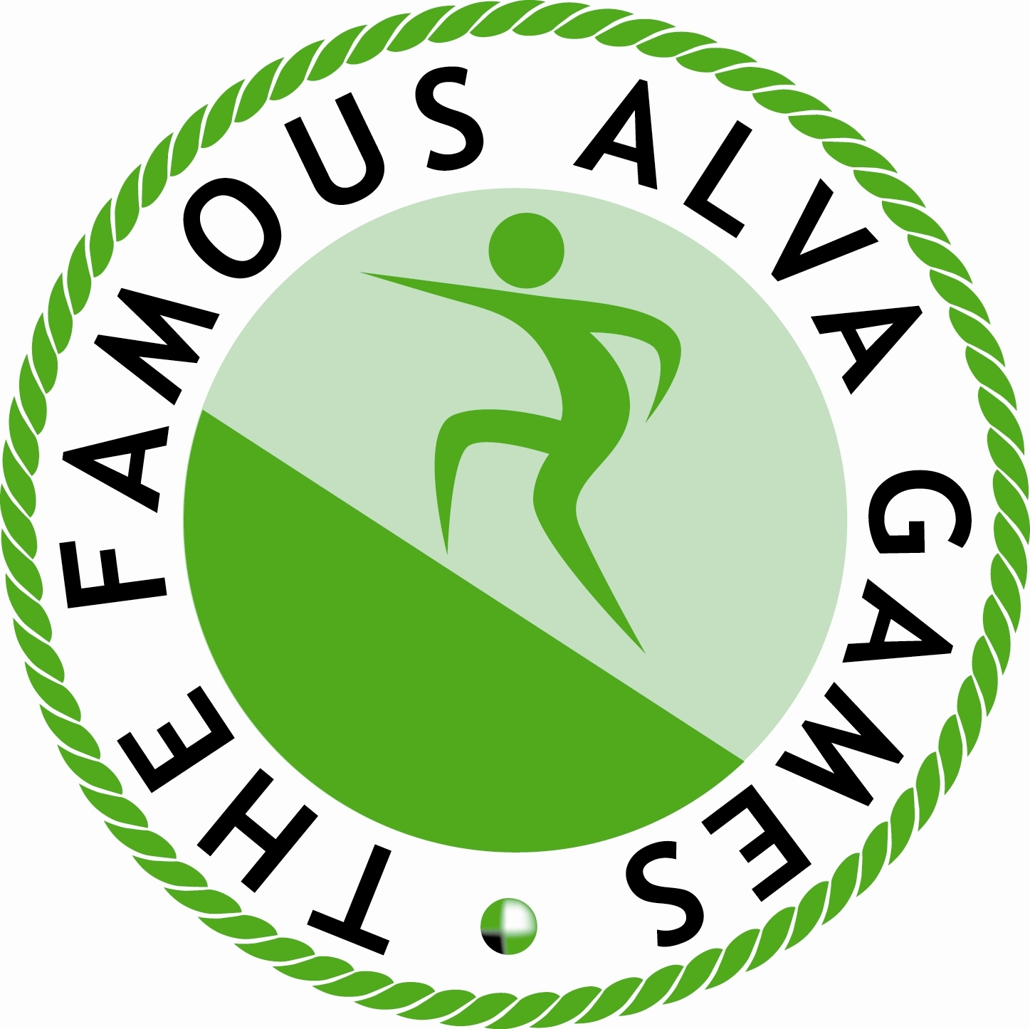

THE 165th FAMOUS ALVA GAMES

Held under the Rules of the Royal Scottish Highland Games Association

Johnstone Park, Alva – Saturday 8th July 2023

OPEN EVENTS COMMENCE AT 12 NOON

ONCE ENTERED BY DEADLINE BELOW, DECLARATIONS TO COMPETE IN 90 METRES RACES CLOSE ON THE DAY AT 11.45AM PROMPT

Name………………………………..
Address……………………………………….
……………………………………………… Post Code………………………………..

Date of birth……………………….. (youth competitors only – youth runners must be 15 or under on May 20th 2023 – minimum age = 9)

Please CIRCLE the events in which you wish to take part:- (This form is for track running events only)

ADULTS

90m 200m 400m 800m 1600m 3200m

YOUTHS

90m 200m 400m 800m 1600m

If you are a new competitor to the highland games circuit please enclose a brief resume of your recent performances either at school sports or any other athletics meeting at which you have taken part along with a note of your times for these races and, where available, personal best times.

Please then return this form to the handicapper, Don Campbell, 4 Paxton Crescent, Lochgelly KY5 9ET (01592 781467) (E-mail: - mdcampbell@btinternet.com ) along with appropriate entry fee of £7.00 all in for adults and £4.00 all in for children. Cheques or postal orders payable to Don Campbell.

I agree to abide by the rules of the RSHGA and of the games committee and accept the jurisdiction of the RSHGA to determine all matters arising out of my competing at these games. I agree to undergo random drug testing if required at this meeting.

Signed……………………………….................……………….Date………………………

Please send SAE to the handicapper to receive entry ticket to the field.

ENTRIES CLOSE SATURDAY 1st JULY 2023

Do not miss this date as NO late entries will be permitted

