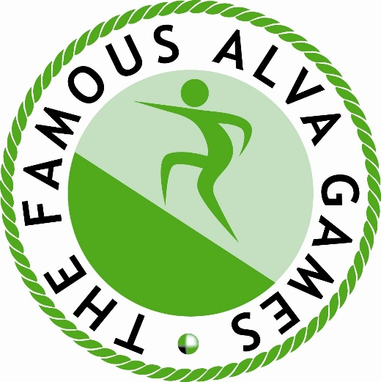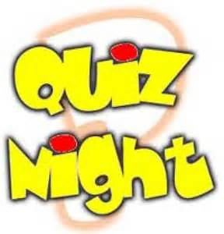

Alva Games Quiz Night
Tuesday 9th July at 7.30pm
No. 5 Inn, Brook Street, Alva

Entries are invited from teams of up to 4 people

FREE entry

Prizes for first 3 teams

For further details contact Jamie Sharp at jss82@tiscali.co.uk

