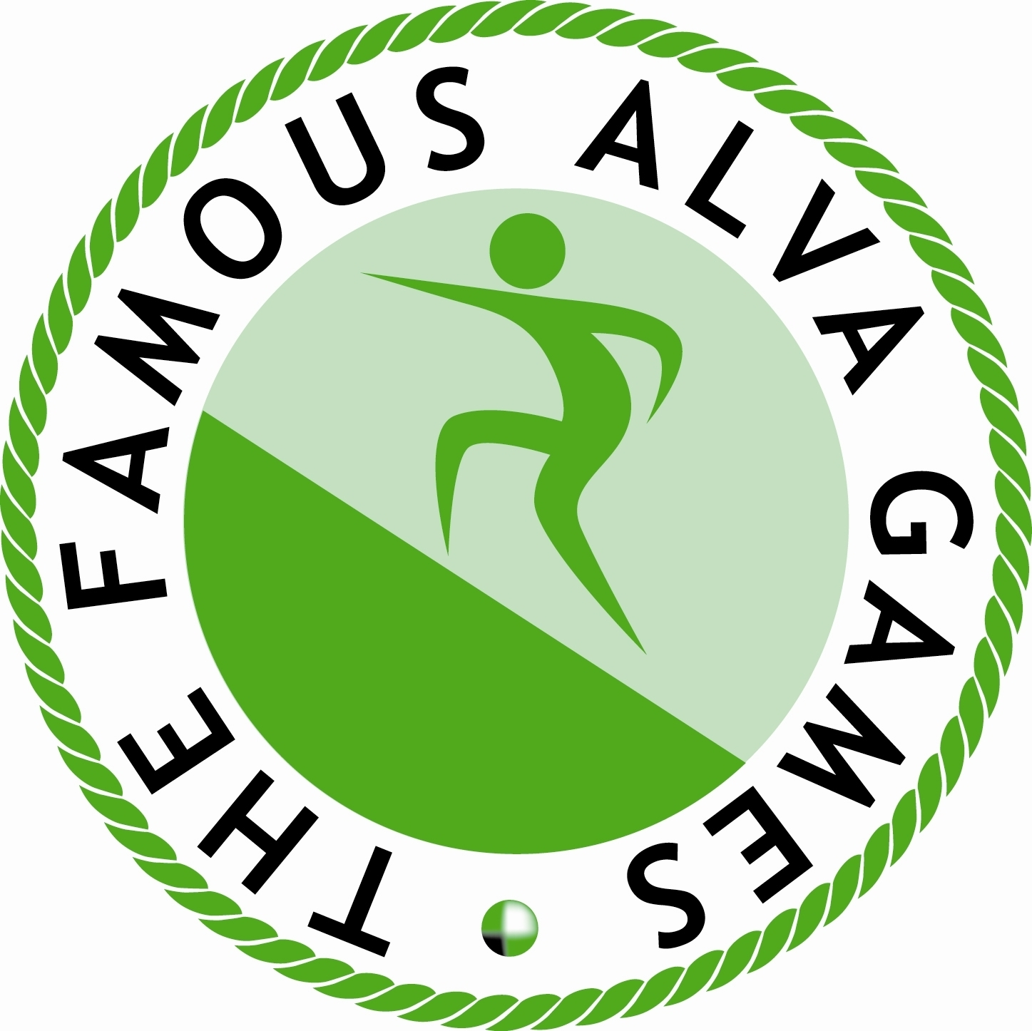

13th ANNUAL BEST DRESSED WINDOW COMPETITION
JUDGING - TUESDAY 10th JULY 2018

For this, the 13th year of this contest, the Games Committee is delighted that our newest Committee member, Jamie Sharp, has agreed to take over the organisation of this contest from Margaret Malcolm and Doreen Harvey, who have both been pivotal in it since its inception, and that he will be organising this prestigious competition.

The theme of the competition for 2018, given that it is the centenary of the end of the Great War is ALVA ARMISTICE CENTENARY. As always, beyond the title of the competition, there are no guidelines – use your imagination and flair to come up with a colourful and intriguing display to have the judges standing in awe. The judges have to assess five areas – colour, attractiveness, originality, reflection of the theme and clever design. Above all, does it have a feel good factor?

The winner will receive the Alva Games Trophy and cash prizes of £85, £50 and £25 for the first three places and special “thank you” prizes for all competitors will be offered to the most successful window displays as judged by our panel of judges which will comprise representatives of the community and Games Committee. The winner keeps the trophy for display until the following June. Everyone taking part, however, will be awarded a certificate to mark their participation. Ultimately, the whole town is the winner as the colourful displays of the past twelve years have proven only too well.

If you are willing to participate in this year’s competition – and try to take the top prizes - please complete the tear off slip below and return it to Jamie who is delivering this to you today. If you are not able to give a commitment to him now, please arrange a time with him to return to confirm the position. Above all, please enjoy taking part – it is your town and your chance to shine in it!

NAME OF BUSINESS………………………………………………………………..

ADDRESS……………………………………………………………………………..

We wish / do not wish to participate in the 2018 Best Dressed Shop Window Competition (please delete as appropriate)

